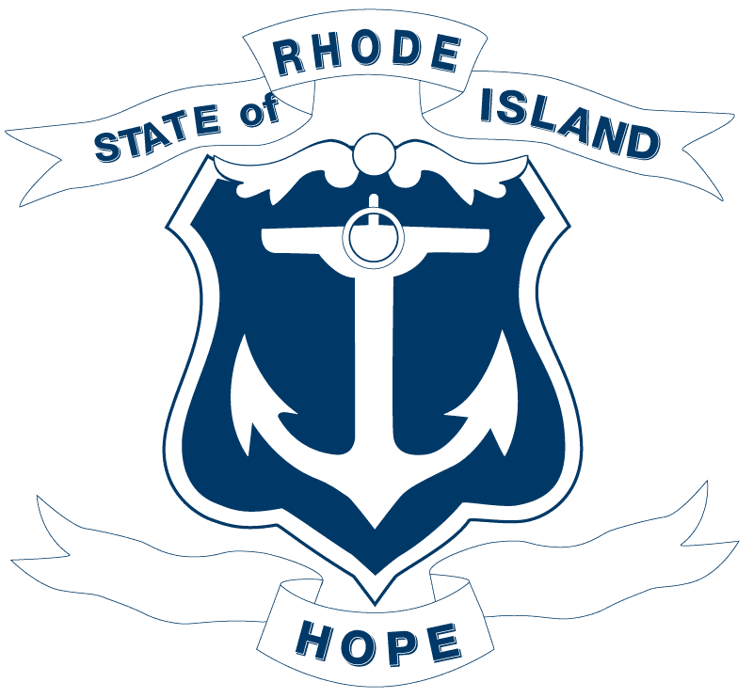

2026 LEGISLATION ANALYSIS
CONFIDENTIAL WORKING DOCUMENT

Analysis Prepared by:
Date:

- Bill number(s): H7003
- Description of bill:
RELATING TO EDUCATION -- HEALTH AND SAFETY OF PUPILS

- Policy analysis:

  - What does this bill seek to accomplish/why was it introduced?
This is entirely new legislation adding Section 16-21-44 to Rhode Island General Laws Chapter 16-21 ("Health and Safety of Pupils"). The bill directs the Department of Elementary and Secondary Education (DESE), in conjunction with the Rhode Island Interscholastic League (RIIL), to establish a statewide anti-hazing policy for student athletics.
Key provisions of the required policy include:
- Definitions: A comprehensive definition of hazing, guided by (but not limited to) conduct that humiliates, degrades, abuses, or endangers a person in a group setting.
- Zero Tolerance: An explicit zero-tolerance standard with consistently and transparently applied discipline across the state.
- Sanctions and Penalties: Consequences for students and student-athletes who engage in hazing, including team suspension, defined suspension periods, and — where appropriate — team-level consequences up to and including cancellation of a team's season.
- No Consent Defense: Consent by the person subjected to hazing is explicitly not a valid defense.
- Education and Prevention: Components connecting to statewide school climate, anti-bullying, and anti-hate initiatives.
- Student Acknowledgment: Each student-athlete must sign an acknowledgment of the policy and its penalties *before* participating in any team practices, meetings, games, or other functions.
- Applicability: All schools and districts participating in the RIIL are subject to the policy.

  - Who are the groups pushing for this bill/asked for it to be introduced? What is its backstory?

  - Which groups supported this legislation?

  - Which groups opposed or expressed concerns with this legislation?

  - Did any Departments weigh in on this bill? Please include letters.

  - Does this bill have a fiscal impact to the State? Business? Taxpayers? If so, please include fiscal note.

  - If this bill is signed into law, would RI be an outlier among other states? Do other states have similar laws? Does Massachusetts or Connecticut?
Several states in the Northeast have enacted anti-hazing legislation with varying degrees of specificity:
- Massachusetts: Massachusetts enacted the Act Prohibiting Hazing (M.G.L. Chapter 269, §§ 17–19), which criminalizes hazing and requires schools and colleges to distribute anti-hazing policies annually. However, it focuses primarily on criminal penalties rather than a comprehensive administrative policy framework for interscholastic athletics specifically. Massachusetts law does not explicitly address team-level consequences such as season cancellation.
https://malegislature.gov/Laws/GeneralLaws/PartIV/TitleI/Chapter269/Section17
- Connecticut: Connecticut passed Public Act 23-111 (2023), which strengthened school anti-hazing requirements, including mandatory reporting and training for school staff, and expanded the definition of hazing. Connecticut's approach similarly emphasizes school-level policies and education but does not specifically empower the state interscholastic league to jointly promulgate a unified statewide athletics-specific policy.
https://www.cga.ct.gov/2023/act/Pa/pdf/2023PA-00111-R00SB-00004-PA.PDF
- New York: New York's Education Law § 2801-a requires school districts to adopt codes of conduct that address hazing, but there is no centralized, interscholastic-league-driven anti-hazing policy specifically for student athletics comparable to what H7003 proposes.
- New Hampshire: New Hampshire's RSA 631:7 criminalizes hazing and requires educational institutions to adopt anti-hazing policies, with penalties for both individuals and organizations. The New Hampshire approach is largely criminal and institutional rather than sport-specific.
https://www.gencourt.state.nh.us/rsa/html/LXII/631/631-7.htm
- Maine and Vermont have anti-hazing statutes with criminal penalties and institutional policy requirements, but neither features a structure that jointly involves the state education department and the state interscholastic league in co-developing a unified athletics-specific policy.
Distinguishing Feature: Rhode Island H7003 is notable for its joint agency approach (DESE + RIIL), its explicit authorization of team-level consequences including season cancellation, and its statewide standardization mandate — features not commonly found together in comparable New England legislation.

  - What is the difference between the original bill and the Sub A version if applicable?

  - Is there anything else the Governor should know about this bill?

- Policy Position: Sign/No Sign/Veto
Rationale:
Policy Director Comments:

Leg. Affairs Comments:

Senior Staff Comments:

Legal Comments:

