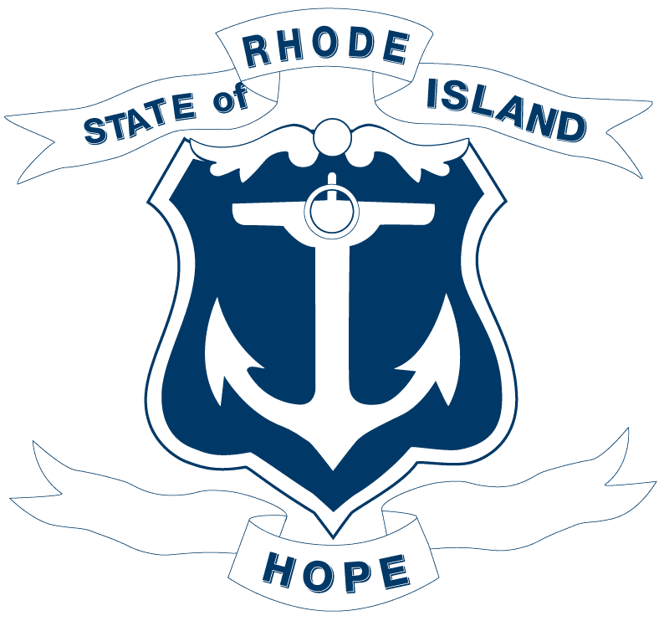

2026 LEGISLATION ANALYSIS
CONFIDENTIAL WORKING DOCUMENT

Analysis Prepared by:
Date:

- Bill number(s): H7006
- Description of bill:
RELATING TO TAXATION -- SALES AND USE TAXES -- LIABILITY AND COMPUTATION

- Policy analysis:

  - What does this bill seek to accomplish/why was it introduced?
H7006 amends Rhode Island General Laws § 44-18-30B, which provides a sales tax exemption for original works sold by Rhode Island-based writers, composers, and artists. The existing law established a statewide arts district program offering sales tax exemptions for "one-of-a-kind, limited-production" works across categories including books, plays, music, visual art, sculpture, crafts, film, and dance.
The bill makes two substantive changes to the existing statute:
- Definition of "book or other writing": The bill adds a new definition clarifying that a qualifying "book or other writing" is a one-of-a-kind, limited production work sold in up to 1,500 copies, regardless of how it is published or sold. This sets a clear numerical ceiling for what qualifies under the exemption.
- Exclusion of certain sales channels: The exemption is denied for third-party electronic sales (e.g., Amazon or similar platforms) and sales through bookstores, gift shops, and other retail outlets. Only direct sales by the qualifying artist/writer retain the exemption.
- Annual reporting requirement: The bill adds a requirement that the tax administrator, in cooperation with the Rhode Island Council on the Arts, gather data and issue an annual report assessing the program's impact on employment, tourism, sales, and spending in the arts sector and adjacent businesses.

  - Who are the groups pushing for this bill/asked for it to be introduced? What is its backstory?

  - Which groups supported this legislation?

  - Which groups opposed or expressed concerns with this legislation?

  - Did any Departments weigh in on this bill? Please include letters.

  - Does this bill have a fiscal impact to the State? Business? Taxpayers? If so, please include fiscal note.

  - If this bill is signed into law, would RI be an outlier among other states? Do other states have similar laws? Does Massachusetts or Connecticut?
Rhode Island's statewide arts district sales tax exemption program is notably broader than what exists in most other states. The specific changes in H7006 — defining qualifying book sales by copy count and restricting the exemption to direct sales — have limited direct parallels in neighboring states.
- Massachusetts has no comparable statewide sales tax exemption for artwork or written works sold by individual artists or writers. Massachusetts does exempt sales of certain arts and crafts at qualifying events under narrow circumstances, but there is no equivalent artist-direct sales tax exemption program.
- Connecticut does not have a general sales tax exemption for art or literary works sold by their creators. Connecticut imposes sales tax on most tangible personal property, including artwork, with limited exceptions.
- New York exempts original works of art from sales tax under N.Y. Tax Law § 1115(a)(23), but this exemption applies broadly to the *purchase* of original artwork and is not structured as a credentialing program for individual artists, nor does it address copy-count limits for books or channel-specific restrictions.
- Maine, New Hampshire, and Vermont do not have comparable structured artist/writer sales tax exemption programs. New Hampshire has no general sales tax, making the comparison inapplicable.
The 1,500-copy threshold for books and the exclusion of third-party and retail sales channels appear to be unique features not found in comparable legislation in these states.

  - What is the difference between the original bill and the Sub A version if applicable?

  - Is there anything else the Governor should know about this bill?

- Policy Position: Sign/No Sign/Veto
Rationale:
Policy Director Comments:

Leg. Affairs Comments:

Senior Staff Comments:

Legal Comments:

